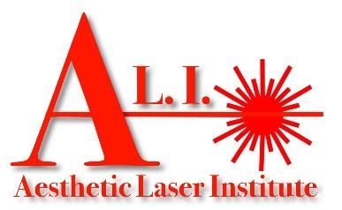 Enrollment Agreement
DATE _______/________/_________ 4114 Florida Ave Suite 6
Kenner, LA 70065
(504) 309-7048 | www.ali-la.com info@ali-la.com

First Name _______________________________________ Middle Initial ___________________ Last Name _______________________________________________ Address ________________________________________________________ City __________________________ State _________ Zip Code ____________________ Primary Phone Number: ______________________________________________ Second Phone #: ____________________________________________________ Date of Birth __________/__________/__________ Age _______________ Social Security __________ - ________ - ____________

High School _________________________________________________ College/Other Education Courses ________________________________________________ Program to Enroll (check )
 Basic Laser Course – 7 day ($6,499.99) Master Laser Course– 10 day (8,499.99)  
In consideration of my acceptance as a student for the ______________________________________________________ program, as of the above date, I hereby enroll and obligate myself to pay to the order of Aesthetic Laser Institute, LLC (write out) __________________________________________________________________________________________________ dollars
($__________________._____) to be paid as follows: (deposit) $____________________._____ with the signing of this enrollment agreement and the balance of $___________________________________.________ to be paid as follows: ____________________________________________________________________________________________ ____________.
Three Business Day Cancellation: I understand that if for any reason I am unable to enter, all monies paid will be refunded if requested within three business days after signing an enrollment agreement and making an initial payment.
Cancellation after the Three Business Day Cancellation Period but Before Commencement of Classes by the Student: Tuition or fees collected in advance of entrance and if the student does not begin classes, not more than $150.00 shall be retained by the institution. Refunds for a student who does not begin classes shall be made within 30 days of notice of cancellation.
I understand that the Withdrawal after Commencement of Classes Refund Policy shall be:
1. After a student has completed less than 15% of the program, the institution shall refund at least 80% of the tuition, less the registration fee, thereafter,
2. After a student has completed less than one fourth of the program, the institution shall refund at least 70% of the tuition, less the registration fee, thereafter,
3. After a student has completed one fourth but less than one half of the program, the institution shall refund at least 45% of the tuition, less the registration fee, thereafter.
4. After a student has completed one half or more of the program, the institution may retain 100% of the stated course price.
*Any unused portion of the book fee will be refunded.
I certify that I have received a copy of the school catalog that contains: my program outline, schedule of tuition, fees, and other charges, the refund policy, regulations pertaining to the rules of operation and conduct, grading policy, and general information. I further certify I have received and read a copy of this Enrollment Agreement and agree to comply with these policies during my period of enrollment in Aesthetic Laser Institute LLC.

Charges:
Tuition Total
Fees Paid/Deductions Total Owed
Student’s Signature
School Representative _______________________________________
Class Date: ______________________________
Date: _____________________ Date: ____________________

